

**Discovering Knowledge**

**COURSE: SEL 401**

**CLOUD COMPUTING**

**PROJECT REPORT**

**CLASS: BSE – 6C (SPRING - 2025)**

**Orrery Web App**

**(Real-Time Solar System and NEO Visualization)**

**Group Members**

|  |  |
| --- | --- |
| **Student Name** | **Enrollment#** |
|  |  |
|  |  |
|  |  |
|  |  |

**Submitted to:**

Course Instructor: **Engr. Maha**

Lab Instructor: **Engr. Sarah**

**Department of Software Engineering**

**BAHRIA UNIVERSITY KARACHI CAMPUS**

**Abstract**

The Orrery Web App is an advanced and interactive 2D web-based system developed to provide users with a real-time visualization of the solar system and Near-Earth Objects (NEOs). This application leverages modern web technologies including a Flutter frontend, Node.js backend, and Firebase services for authentication and real-time database management. By integrating external astronomy APIs, primarily NASA’s NEO API, the application updates users with accurate, current information about planetary positions and nearby asteroids. Users can interactively navigate through the solar system, zoom into specific objects, and access relevant information with ease. The system features Google-based login functionality to ensure secure access, and the entire project has been successfully containerized using Docker, ensuring compatibility across platforms. Both frontend and backend have been deployed on GitHub, with the backend also hosted statically via GitHub Pages for structural reference. This project provides a functional, educational, and interactive experience for astronomy enthusiasts, students, and educators alike.

TABLE OF Contents

1. Introduction 4

2. Problem Statement 4

3. Proposed Solution 4

3.1. Features of the project 4

3.2. Methodology 5

3.3. Technologies 5

3.4. Technologies to be used 5

4. Software Design Description 6

4.1. Design Overview 6

4.2. Work Flow Diagram 6

4.3. Use Case Diagram 7

4.4. Sequence Diagram 8

4.5. ER Diagram 9

4.6. Block Diagram 10

4.7. Screen Images 11

5. Project Scope 14

6. Module Distribution 14

7. Code 14

8. Containerization & Deployment 16

9. Conclusion 17

10. References 17

# Introduction

Celestial phenomena have captivated human imagination for millennia. In the contemporary age of information and technology, the ability to explore astronomical data visually and interactively has become both a possibility and a necessity, especially in education. The Orrery Web App project arises from the need to make such exploration accessible, real-time, and engaging. Traditional models are often static or outdated, limiting the user’s ability to visualize planetary motions or understand the current position of NEOs.

This project bridges the gap by offering an application that integrates real-time astronomical data with a responsive user interface, thereby enabling a deeper understanding of space for students, enthusiasts, and educators.

# Problem Statement

Despite the existence of various digital astronomy tools, most suffer from either outdated data, lack of interactivity, or technical complexity. Many applications fail to provide real-time updates, offer a limited user interface, or do not support modern deployment strategies such as containerization or mobile-responsiveness. Additionally, security and user management are often overlooked.

The problem is clear: there is a lack of accessible, real-time, interactive astronomy platforms that can be used for educational or informational purposes by users of all backgrounds. This project seeks to solve these problems by offering a secure, real-time web app with interactive capabilities and modern deployment support.

# Proposed Solution

To address the issues in existing systems, we have developed a 2D interactive Orrery Web App that visualizes planetary positions and NEOs in real time using data from NASA’s NEO API. The application is structured to be intuitive, secure, and educational. It is built using a modern tech stack comprising Flutter for the frontend, Node.js for the backend, and Firebase for both authentication and database services. The application runs within a Docker container to ensure easy deployment across different systems. Users can explore space through a smooth interface that updates in real time with live astronomical data. The entire system is deployed on GitHub, and the backend is also deployed statically via GitHub Pages for reference purposes.

## Features of the project

* **Real-time Data Integration:** Planetary positions and NEO details are fetched using external APIs (e.g., NASA NEO API) and updated in the application in real time.
* **Interactive Visualization:** Users can pan and zoom across a 2D model of the solar system to explore specific planets, asteroids, and other celestial bodies.
* **Google Authentication:** Firebase Authentication allows users to log in securely using their Google accounts.
* **Firestore Database:** Real-time data is stored and managed using Firebase Firestore, enabling efficient and dynamic data handling.
* **Cross-platform Frontend:** The UI is built with Flutter, allowing for a clean, responsive, and platform-independent design.
* **Docker Containerization:** The project is packaged using Docker, making it portable and easy to deploy across environments.
* **GitHub Deployment:** The entire source code is version-controlled and hosted on GitHub, with the backend also deployed statically on GitHub Pages for demonstration.

## Methodology

* **Requirement Gathering:** Studying existing systems and identifying pain points.
* **Data Source Identification:** Using NASA or other APIs to fetch real-time planetary data.
* **Frontend Development:** Creating UI components with Flutter.
* **Backend Development:** Implementing logic in Node.js to interact with APIs and the database.
* **Firebase Integration:** Setting up Firestore and Authentication modules.
* **Containerization:** Packaging app using Docker.
* **Deployment:** Hosting on GitHub and deploying backend as static reference on GitHub Pages.

## Technologies

* **Languages:** JavaScript (Node.js) for backend, Dart (Flutter) for frontend.
* **APIs:** NASA NEO API
* **Database:** Firebase Firestore
* **Authentication:** Firebase Authentication
* **Deployment:** Docker, GitHub, GitHub Pages (backend)

## Technologies to be used

* Dart (Flutter)
* JavaScript (Node.js)
* REST APIs
* Firebase platform
* Docker containers
* GitHub and GitHub Pages

# Software Design Description

## Design Overview

The design of the Orrery Web App follows a modular client-server architecture. The frontend, built using Flutter, is responsible for rendering the interactive interface, handling user interactions, and displaying real-time astronomical data. It communicates with the backend via RESTful APIs. The backend, developed in Node.js, handles the logic of fetching real-time data from external APIs like NASA's NEO API, processes it, and then stores or retrieves it from Firebase Firestore. Firebase Authentication secures the system, managing user sessions through Google login. The entire system is containerized using Docker, which enables consistent environments for deployment. This modular approach ensures scalability, maintainability, and cross-platform compatibility. Furthermore, the system supports asynchronous data flow, enabling fast performance and seamless updates to the user interface. The architecture also allows easy integration of future modules like additional celestial body datasets or user profile management.

## Work Flow Diagram

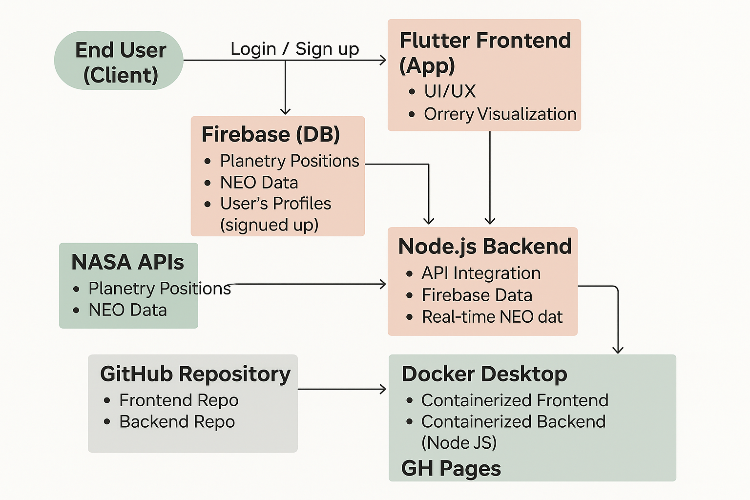

## Use Case Diagram

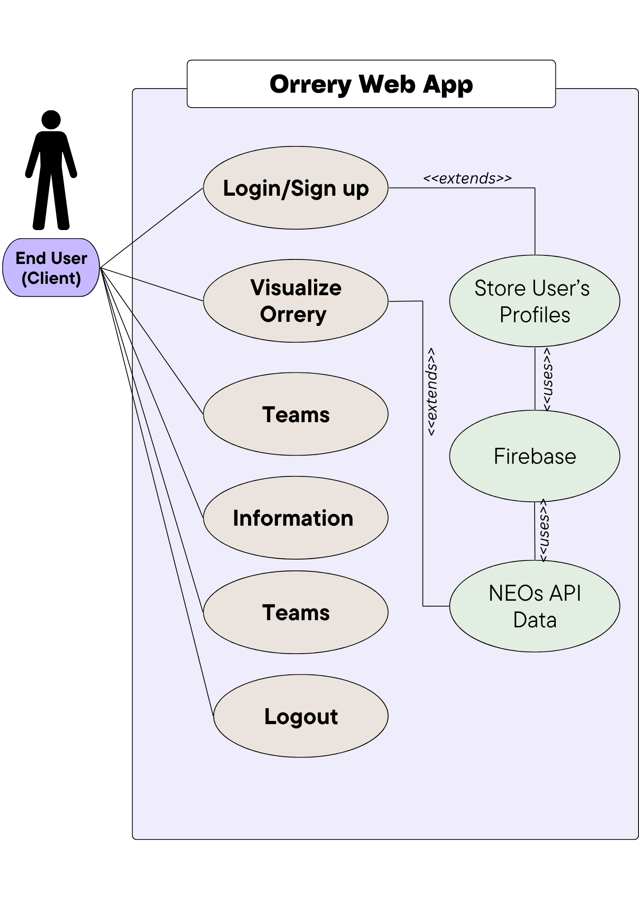

## Sequence Diagram

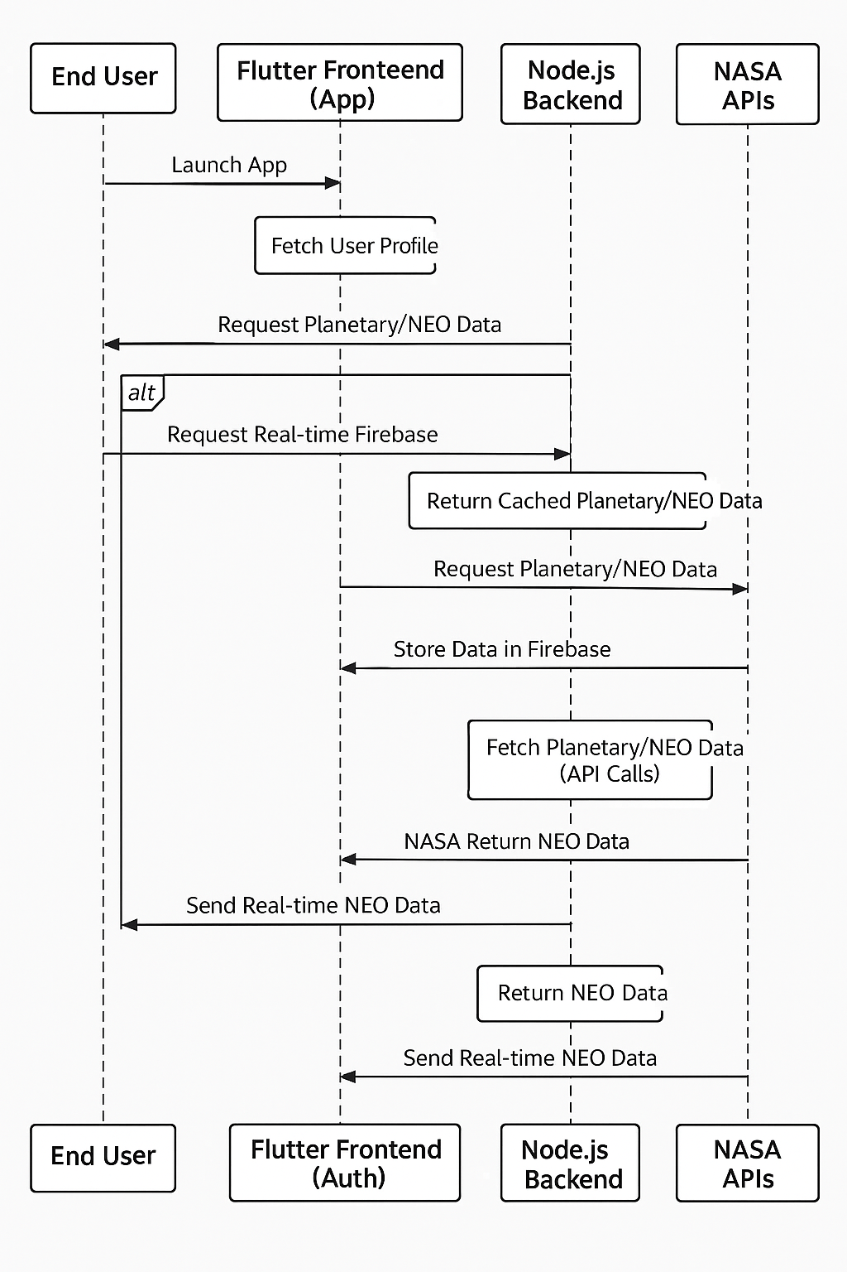

## ER Diagram

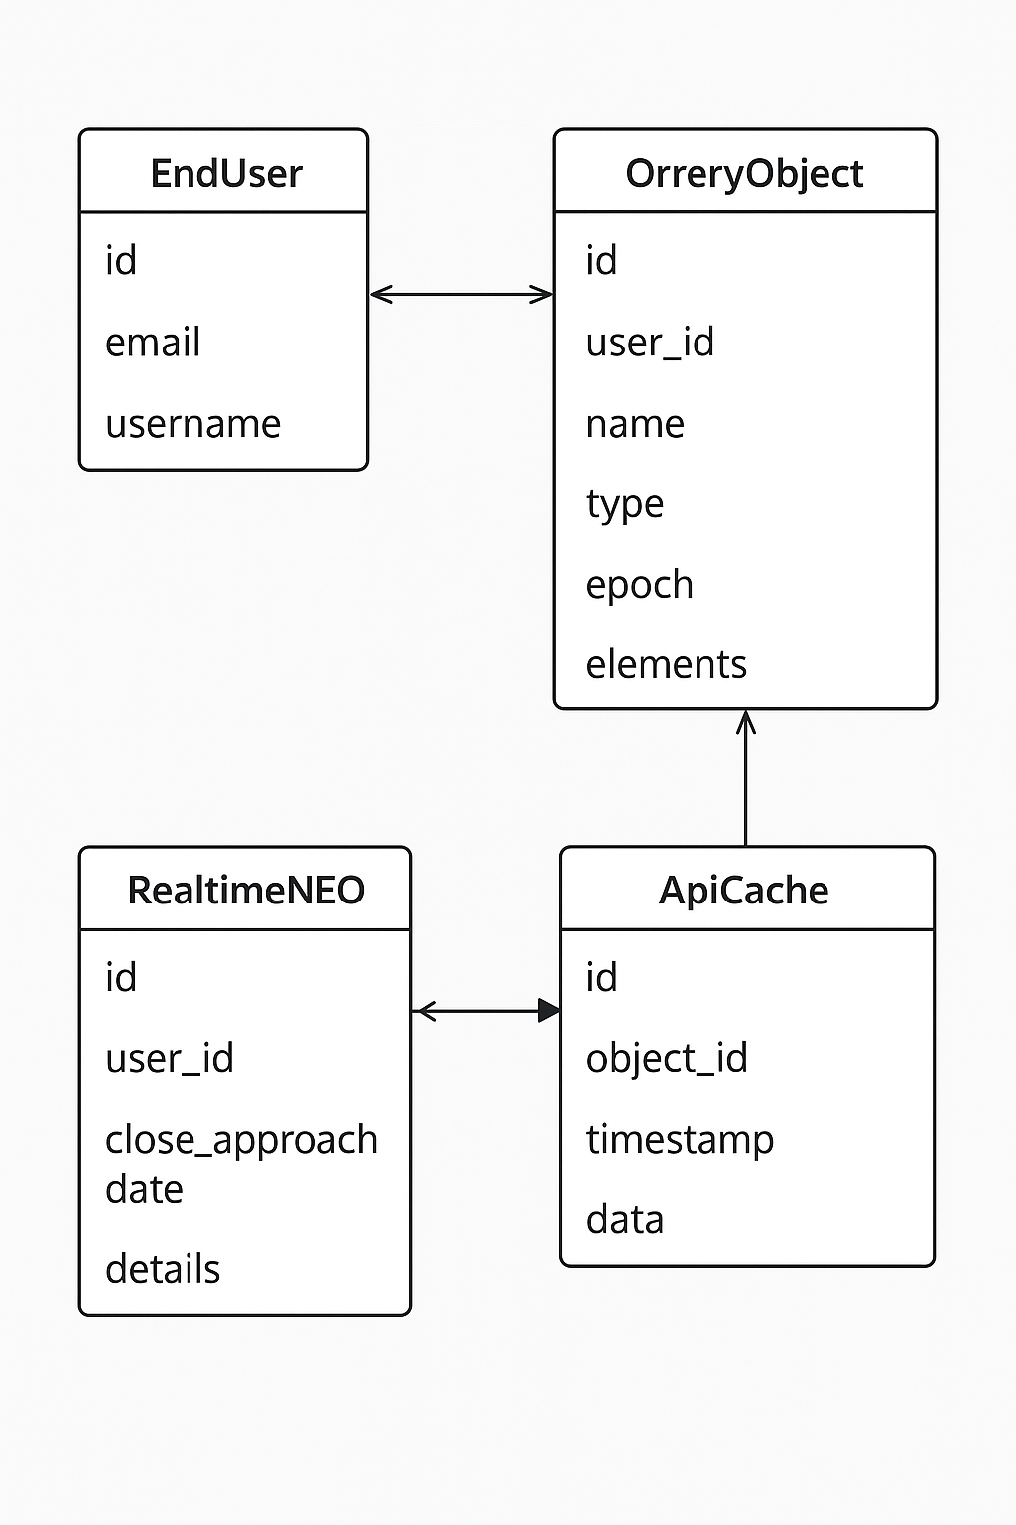

## Block Diagram

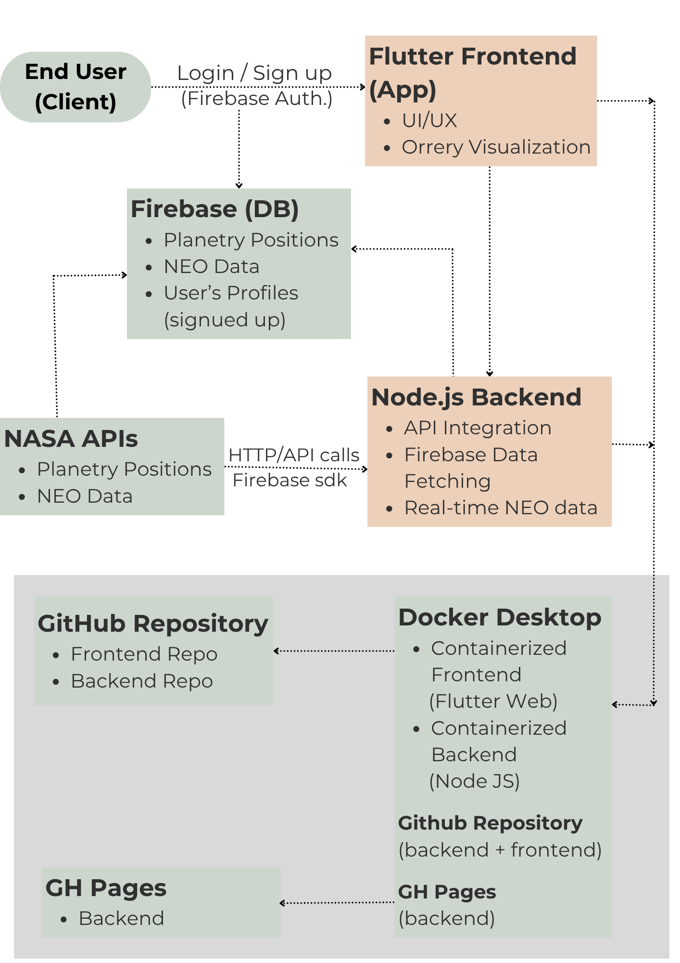

## Screen Images

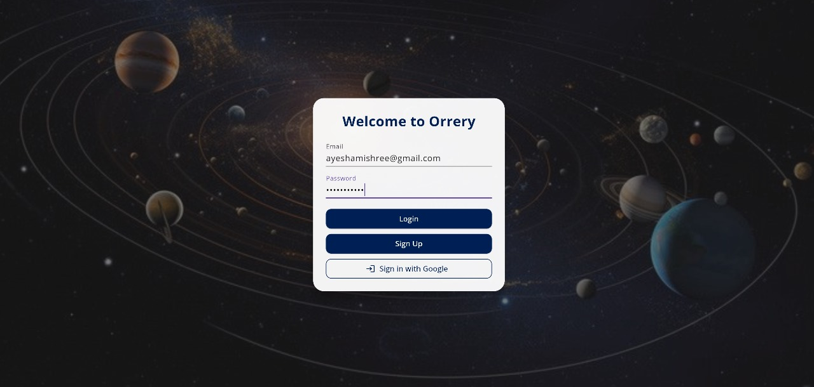

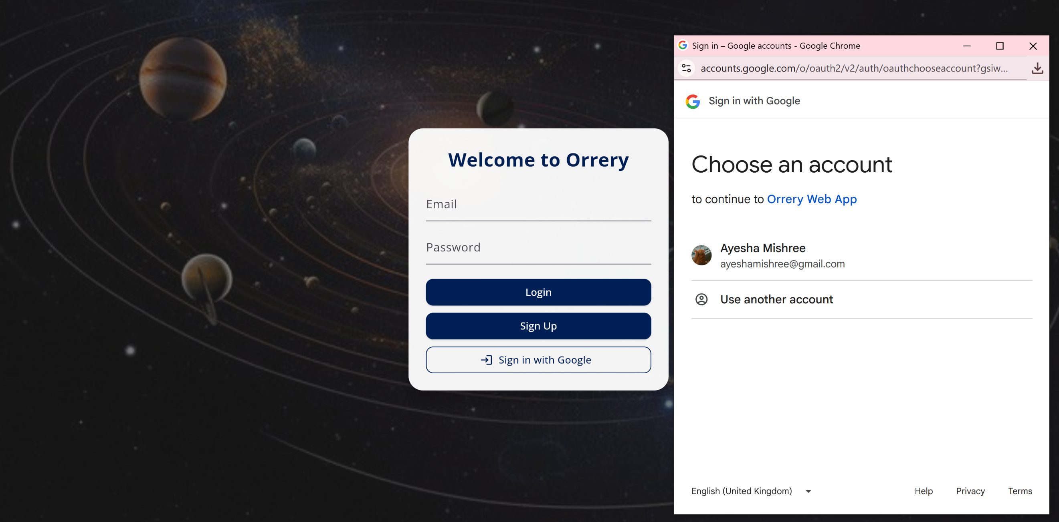

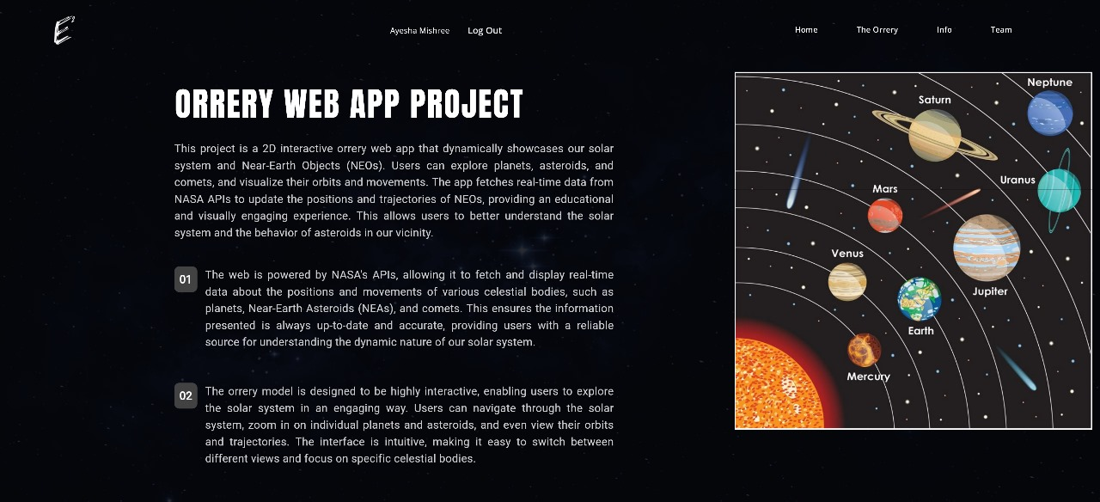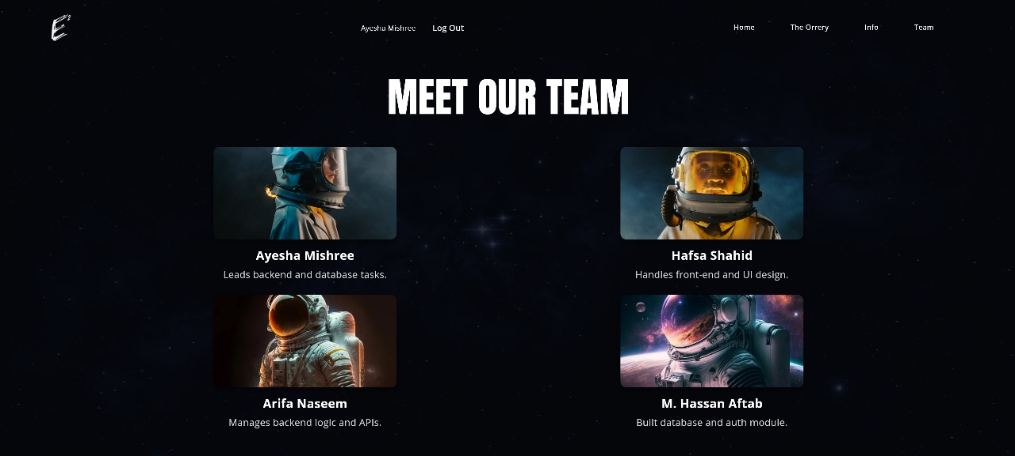

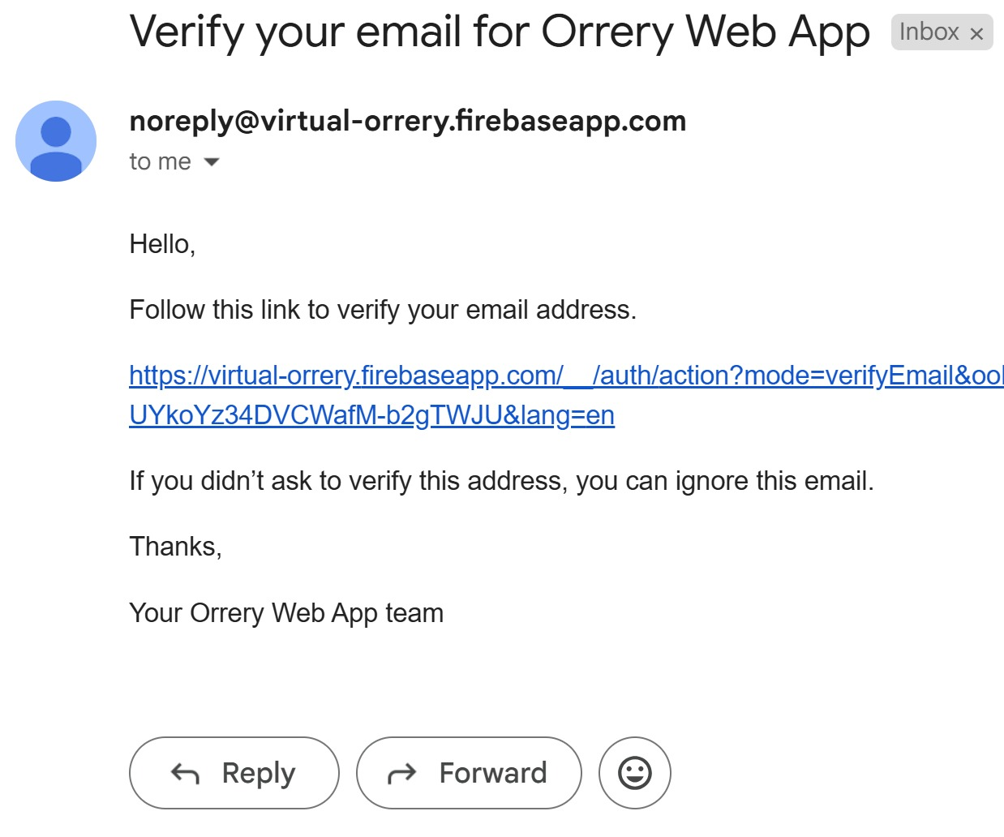

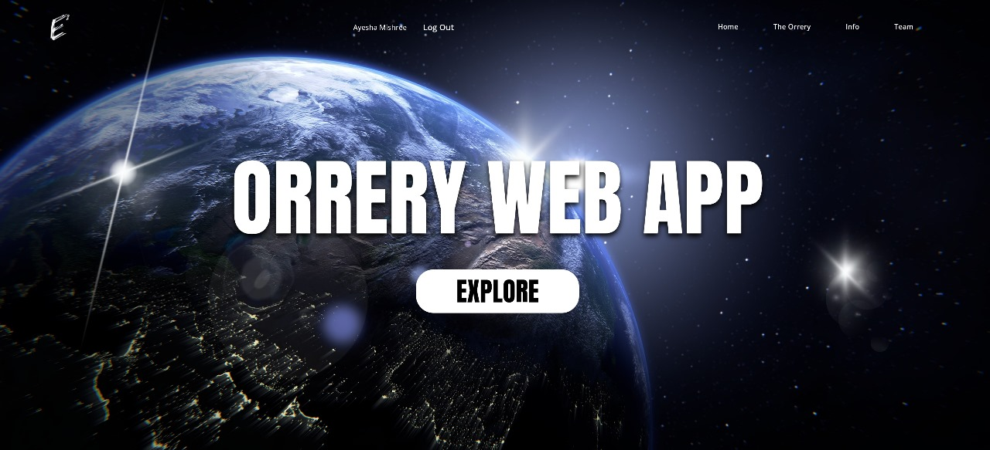

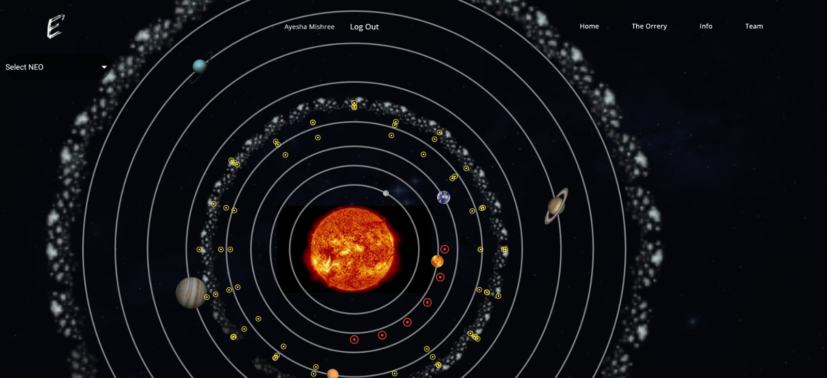

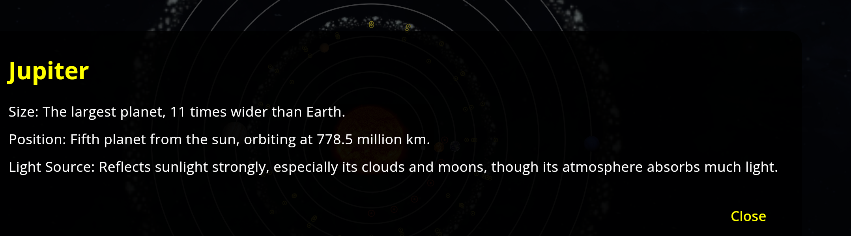

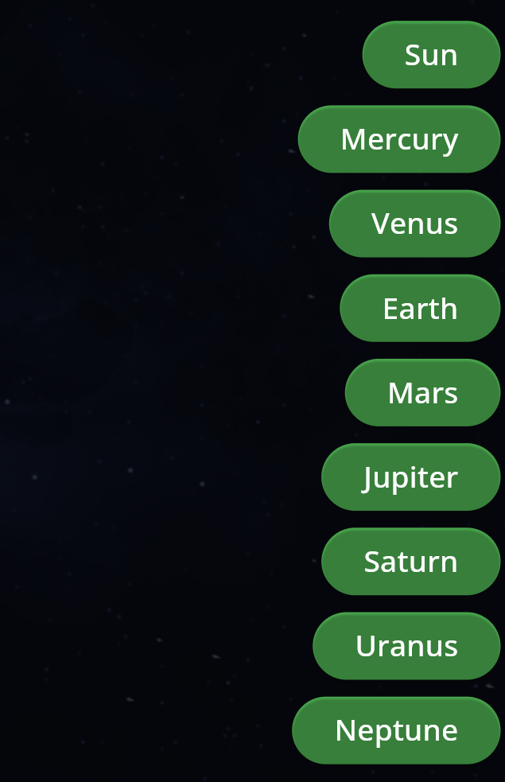

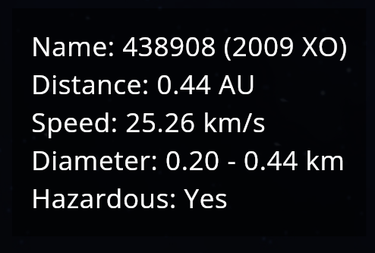

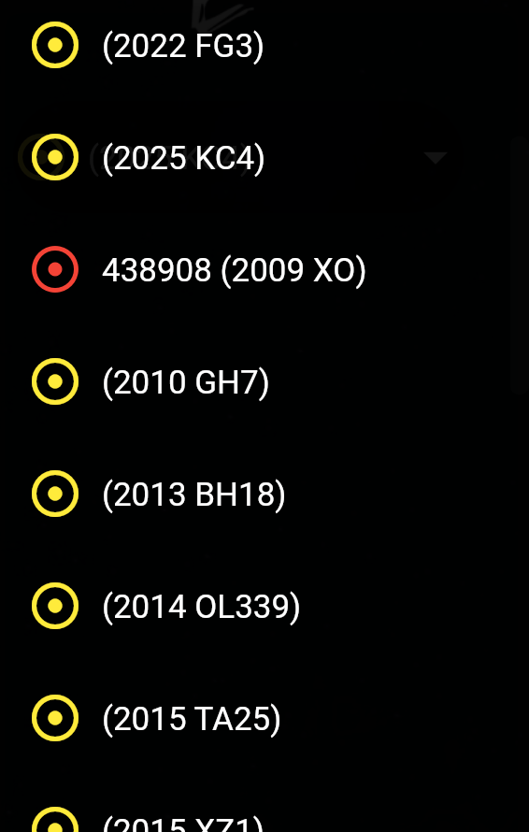



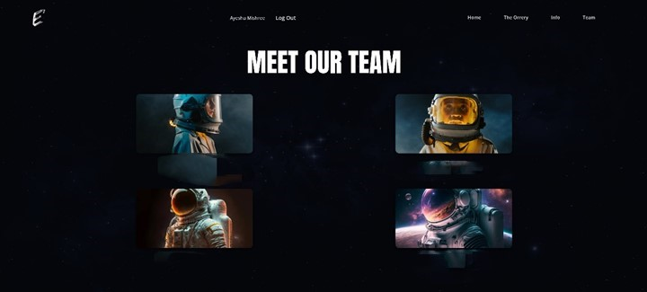

# Project Scope

The Orrery Web App project encompasses the development of a complete web-based system that visualizes the solar system and Near-Earth Objects in real time. The application supports user authentication through Google, real-time data fetching from astronomy APIs, dynamic rendering using Flutter, and backend logic with Node.js. It includes real-time database integration using Firebase Firestore and is fully containerized for portability via Docker. The project scope also includes deployment of frontend and backend repositories on GitHub, with the backend made available via GitHub Pages for static structural reference. The scope does not extend to include predictive algorithms, complex simulations, or mobile app deployment, but the modular design leaves room for such extensions in the future.

# Module Distribution

1. **A (Team Lead):** Developed the backend in Node.js and integrated it with the Flutter frontend.
2. **B:** Designed and implemented the Flutter frontend and connected it with Firebase Firestore for real-time data.
3. **C:** Worked on Firebase Authentication using Google Sign-In, managed external API integration, and handled Firebase database structure.
4. **D:** Managed Docker containerization and handled GitHub deployment, ensuring the project ran successfully in containerized environments.

# Code

Backend Server.js File

Backend NeoRoutes.js File

…………….

Backend NeoRoutes.js File

………………..

………………….

Backend Neo.js File

……………………

Frontend Index.html File

…………………

# Containerization & Deployment

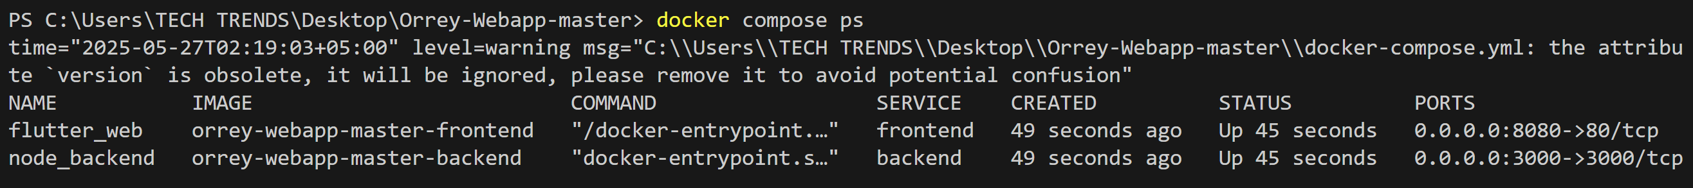

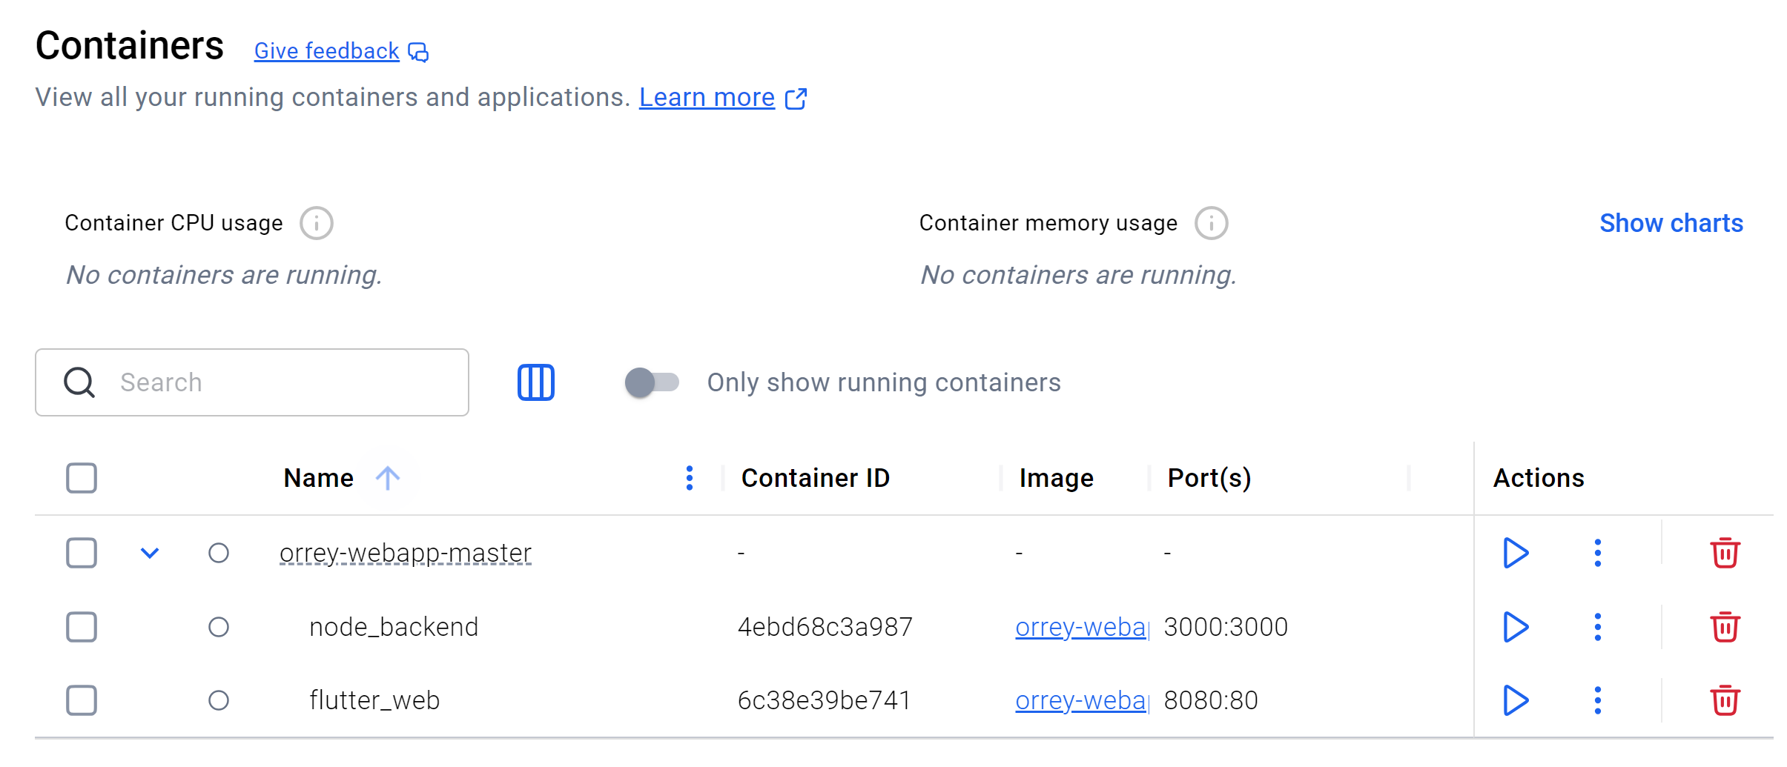

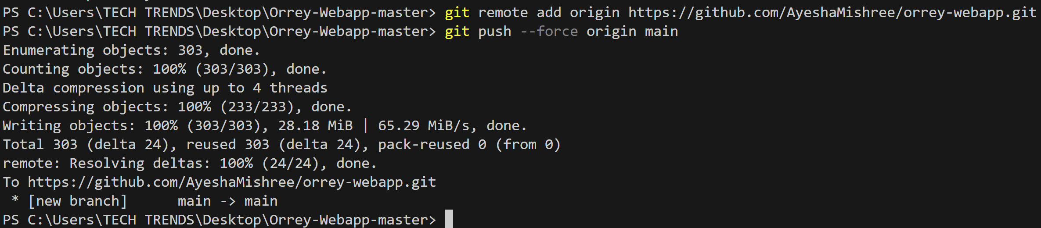

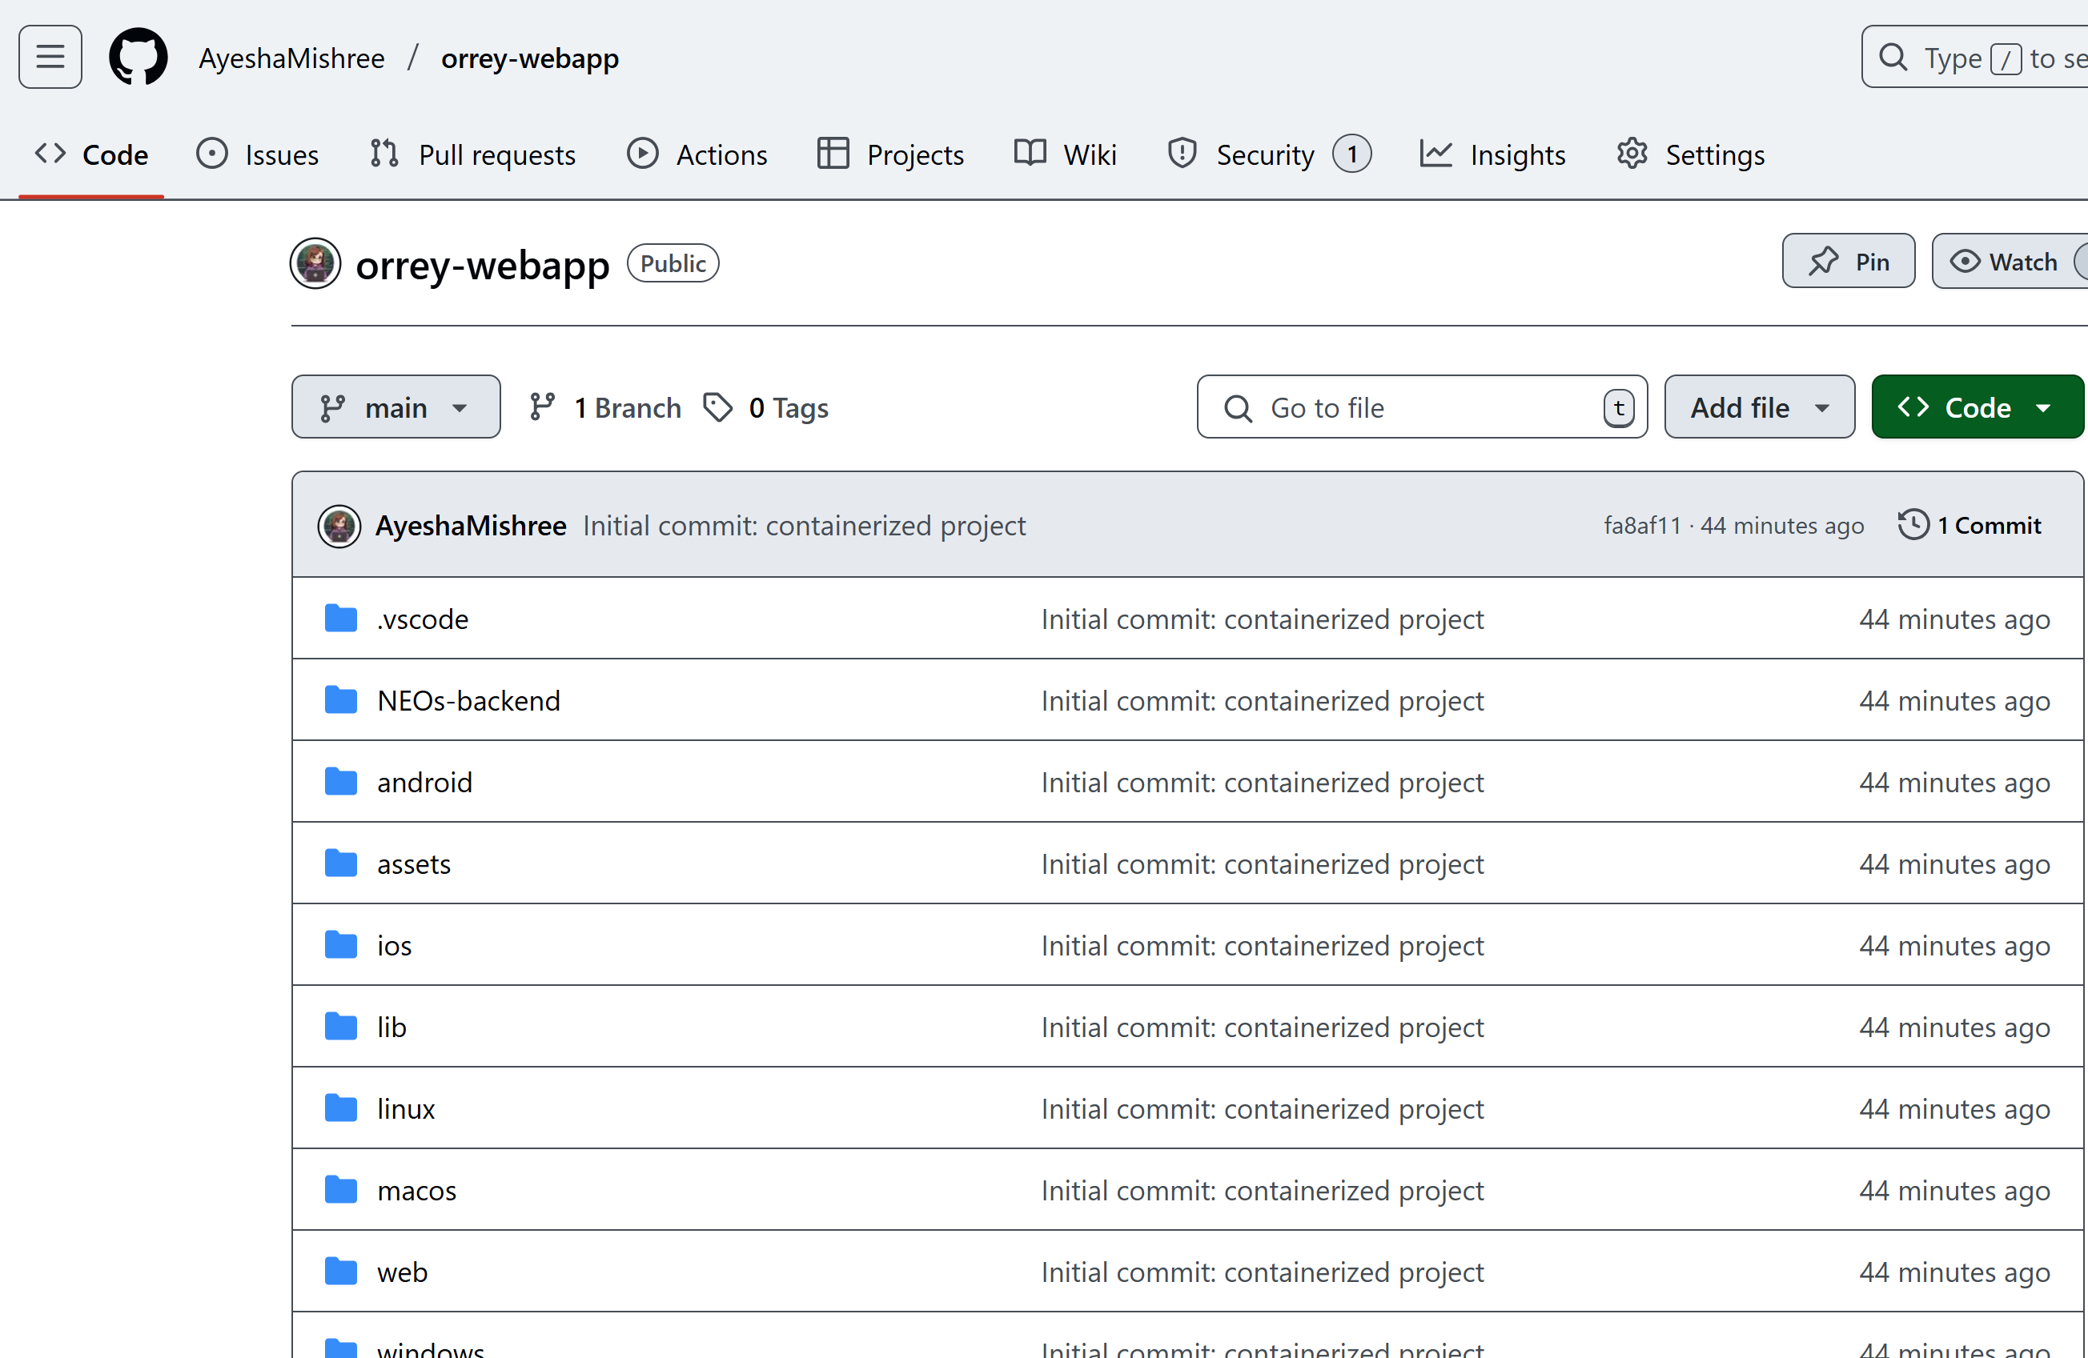

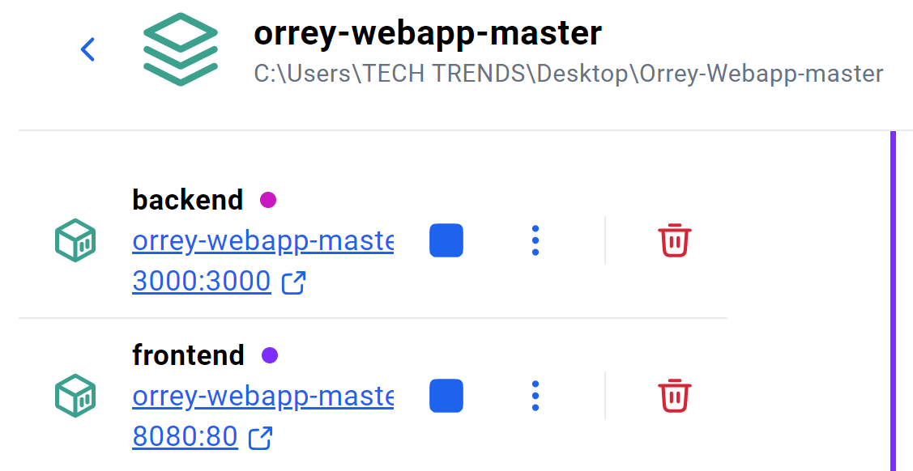

# Conclusion

The Orrery Web App represents a significant step toward interactive, real-time astronomical education. By integrating modern web technologies, Firebase services, and containerization, the project ensures high performance, scalability, and accessibility. Users can securely access the system, explore the cosmos in real time, and understand dynamic spatial relationships. The successful deployment and modular design ensure that the application is both sustainable and extendable.

# References

[1] R. Johnson, “Interactive 3D Visualization of the Solar System,” Journal of Astronomical Education, vol. 58, no. 3, pp. 210–215, 2020.

[2] S. Williams, “Real-Time Data Visualization in Web Applications,” IEEE Transactions on Web Engineering, vol. 22, no. 4, pp. 433–440, 2019.

[3] A. Gupta, “Using Firebase for Real-Time Data Management in Web Applications,” International Journal of Computer Science, vol. 12, no. 5, pp. 55–62, 2021.

[4] NASA, “Asteroids – NeoWs (Near Earth Object Web Service),” NASA API, 2024. [Online]. Available: <https://api.nasa.gov>

[5] Canva, “Online Design and Publishing Tool,” Canva.com, 2025. [Online]. Available: <https://www.canva.com>